**MORPHOLOGICAL CHARACTERS**

When I speak of a character as “asinine” it must be remembered that the character ***in itself*** is ***not*** asinine. What is “asinine” is the ***usual*** ***association*** of this character to all characters usually found in extant Asses***.*** Or, the ***occasional association of this bizarre character*** (for example the “bridge” pattern of lower cheek teeth) to all characters usually found in extant Asses.

I should speak of morph 1, or 2, or X, of the character - rather like a gene and its alleles.

Of course, all morphologies are not as clear-cut as described below; and of course, Asinine characters may occur in Hemiones, etc.

Fig. 1 is a tentative schematic representation of how I see different *Equus* extant species in relation to a few morphologic characters. The cylinder contains a pool of characters from which the species get their morphology.



Fig. 1

**Double knot** morphs of the lower cheek teeth are symbolized by **Circles**.

1. Standard: blue, Fig. 2

Ectoflexids are shallow on premolars, deep on molars.

Metastylids are either rounded or pointed.

Lingual valleys are pointed, inserted between the convex faces of metaconid and metastylid, or flattened, or even convex if pressed upon by very deep ectoflexids.

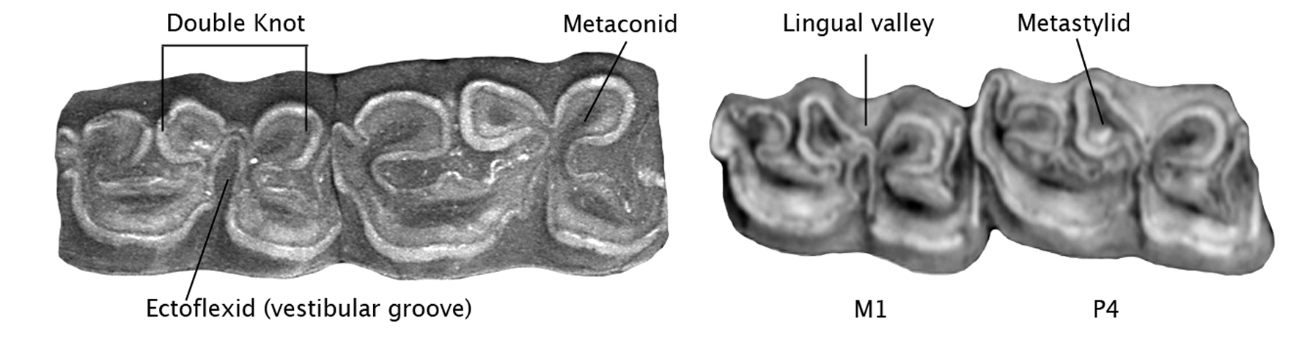

Fig. 2

2. Asinine: yellow

a) Usual, Fig. 3

Ectoflexids shallow on premolars ***and*** molars. Metaconids and metastylids rounded. Lingual valleys pointed, between the convex faces of metaconid and metastylid.

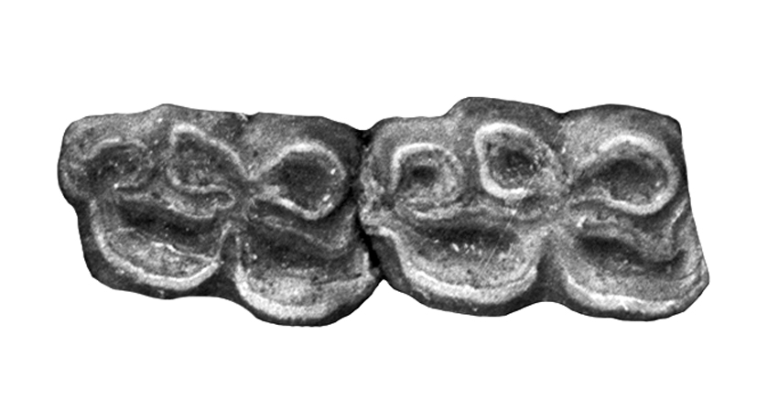

Fig. 3

b) In some Wild Asses, Fig. 4

Ectoflexids shallow on premolars and molars.

Lingual valleys pointed like in the usual pattern ***or*** convex on P and/or M, although there is no compression by the ectoflexid. This sort of « bridge » may look as the posterior part of an elongated and strangled metaconid.

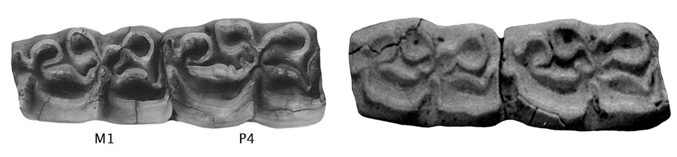

Fig. 4

3. Hemionine: orange

Ectoflexids shallow on premolars and molars.

Lingual valleys shallow, metaconids elongate, Fig. 5.

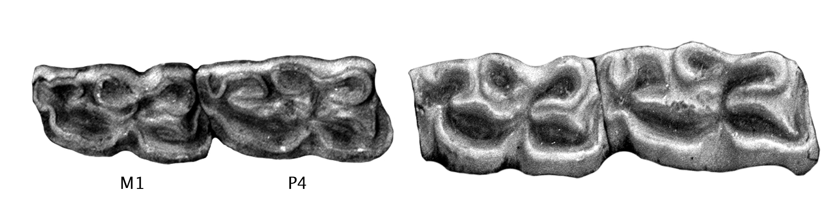

Fig. 5

Occasionally the « bridge » described above is present on premolars or molars, Fig. 6.

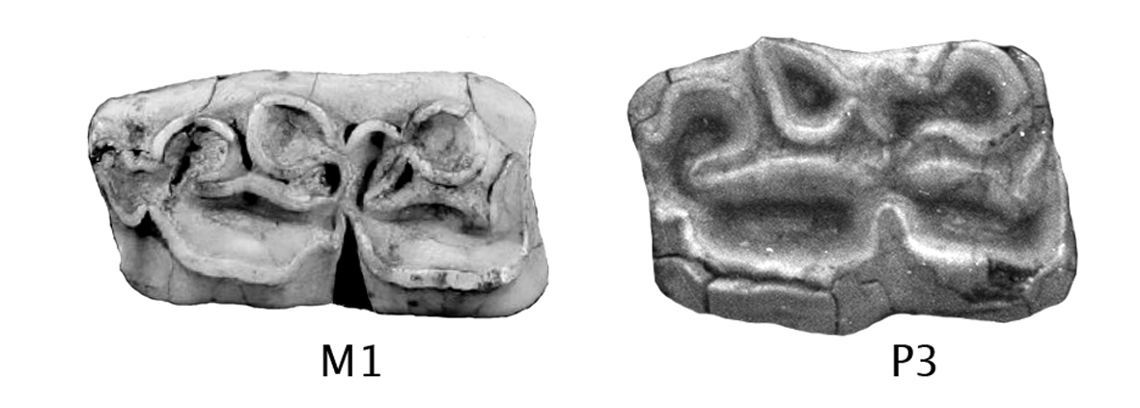

Fig. 6

4. Caballine: red, Fig. 7

Ectoflexids shallow on premolars, shallow ***or*** deep on molars.

Metastylids pointed. Lingual valleys concave or angulated.

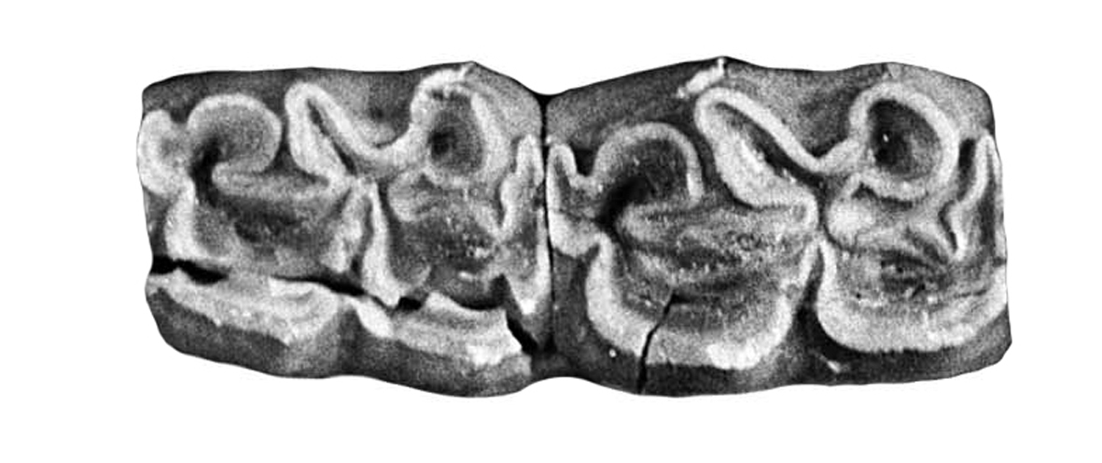

Fig. 7

5. Sussemiones, purple, Fig. 8

Ectoflexids are deep on molars ***and*** sometimes even on ***premolars.***

The enamel is very plicate. Plis protostylid occur on P2 and other teeth. Metaconids are often elongated. Metastylids are usually pointed. Isolated ectostylids are frequent.

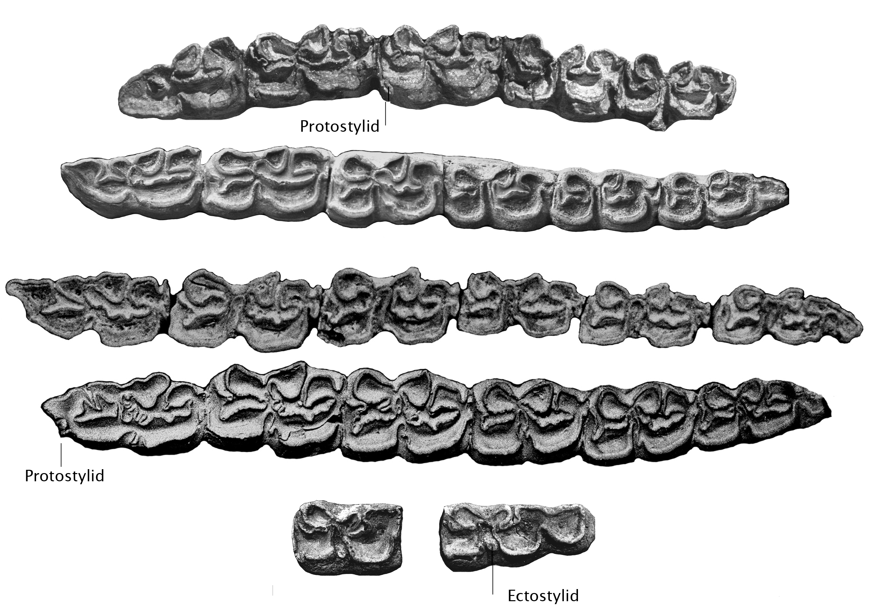

Fig. 8

**Protocone length** is reprsented by **Quadrates**: light blue for short, orange for long (Fig.9).

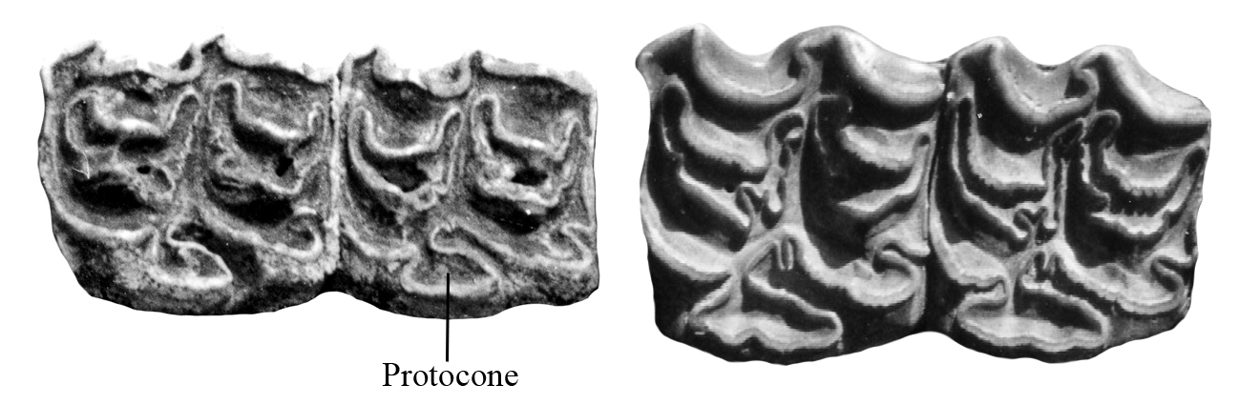

Fig. 9

**Post-Protoconal valley** depth is figured by **Triangles**: light blue for short, orange for deep (Fig. 10).

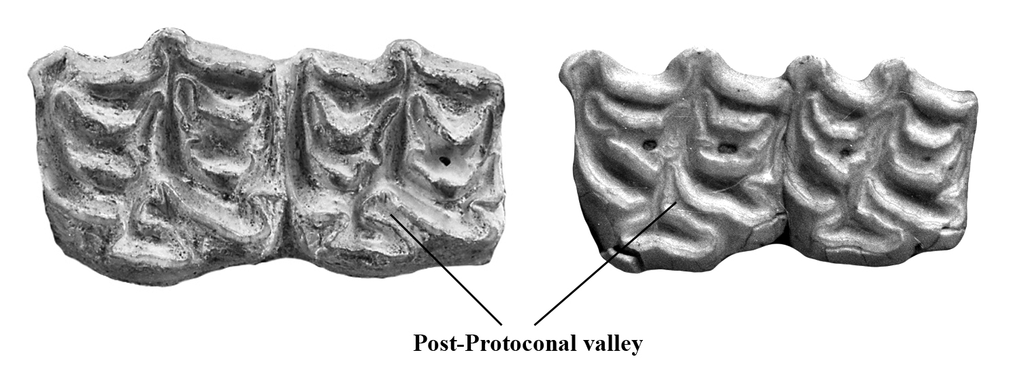

Fig. 10

**Degree of Plication** is represented by **Asterixes**: orange for few, blue for average, purple for many (Fig. 11).

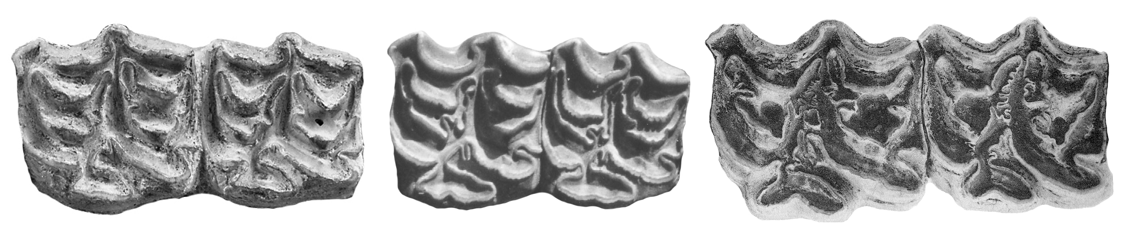

Fig. 11

**Limb bones** morphs are represented by **Lozenges**: orange for hemionine, yellow for asinine, green for Burchell-like.

Obviously, it is impossible to qualify each limb bone in this way. And obviously in the same species, all bones do not belong in a single category. Schematically hemionine bones are most slender, asinine – less so, and Burchell-like – even less.

Here I present a few examples.

**1. First phalanges (Ph1)**

* Asinine first anterior phalanges (Ph1A).

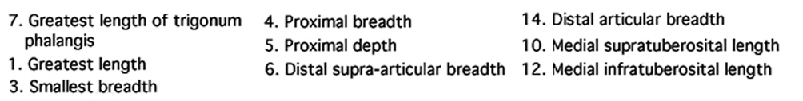

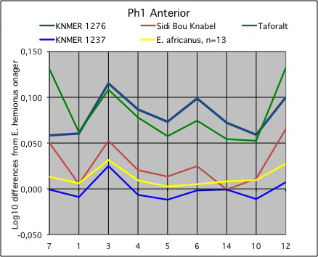

Fig. 13

Figure 13 shows that *E. africanus* Ph1A differ from those of *E. hemionus onager* Ph1A – reference zero line - mainly by being slightly wider (measure 3). The proportions of KNM ER 1237 from Koobi Fora smaller form of MA zone (about 1.5 My old) are nearly identical. Those of the three other fossils may be also classified as “asinine” although their distal supra-articular breadths (measure 6) are wider.

* Asinine first posterior phalanges (Ph1P).

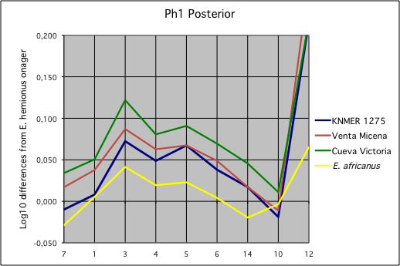

Fig. 14

Figure 14 shows that *E. africanus* Ph1P differ from those of *E. hemionus onager* Ph1A by being slightly wider in the diaphysis and deeper at the proximal end (measures 3 and 5). Of course, since these are **posterior** phalanges, they have also greater supra-tuberosital lengths (measure 12). The proportions of KNM ER 1275 from Koobi Fora *Allohippus* cf. *koobiforensis* of MA zone (about 1.5 My old) and two fossil equids of about the same age are not altogether very different. They may be also classified as “asinine”.

* Grevy-like first anterior and posterior phalanges (Ph1A, P).

Figure 15 shows that the smaller form mentioned above may have phalanges looking more like some *E. grevyi* than like *E. africanus* (Fig. 13 and 14).

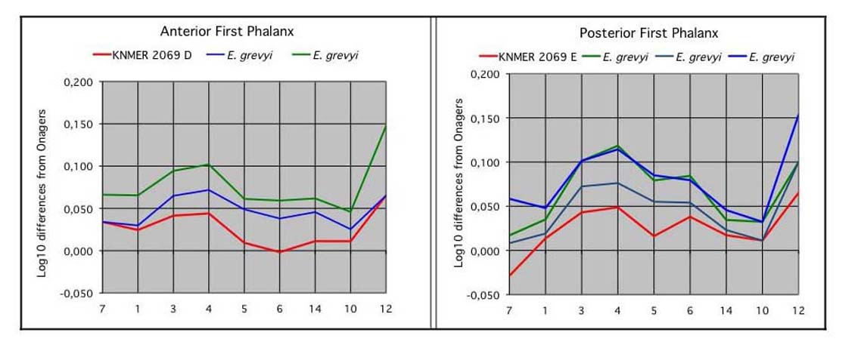

Fig. 15

* Burchell-like first anterior and posterior phalanges (Ph1A, P).

Fig. 16 shows that Burchell-like first phalanges are more robust (measures 1-3) than those of *E. grevyi* (Fig. 15) and Asses (Fig. 13 and 14). Also that these proportions are found at Koobi Fora at around 750 Ky ago.

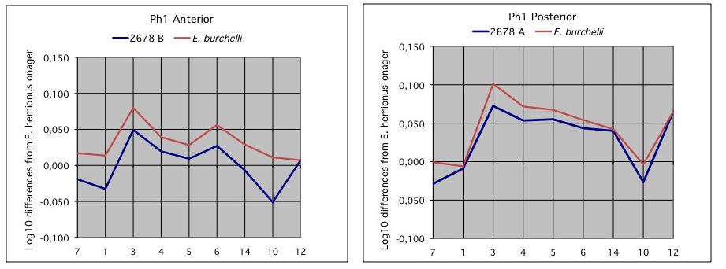

Fig. 16

**2. Tali**

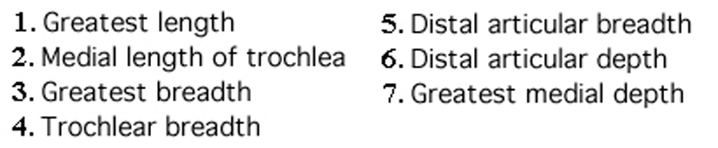

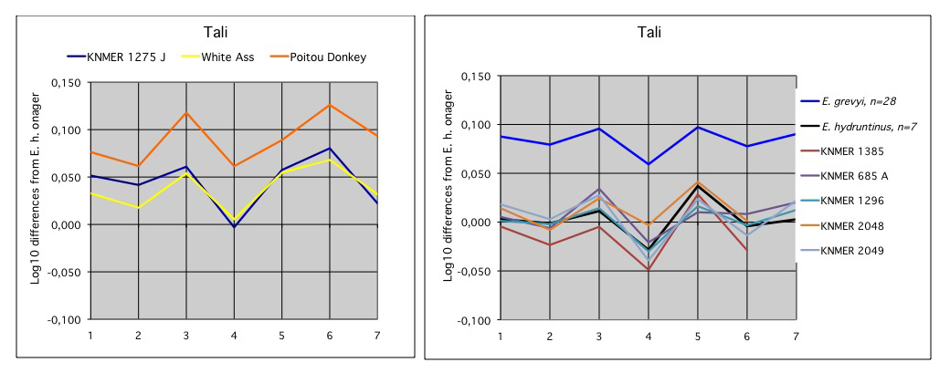

Fig. 17

Figure 17 shows how Tali from Koobi Fora differ from each other, from *E. grevyi*, *E. hydruntinus*, and *E. hemionus onager*, by size and proportions. KNM ER 1275 (referred to *Allohippus* cf. *koobiforensis* of around 1.5 My old) is bigger (all measures) than the reference Onager, has a relatively smaller trochlear breadth (measure 4), and bigger distal articular dimensions (5, 6). Some extant Poitou donkeys and Egyptian White Asses are similar. *E. grevyi* tali have about the same size but differ by broader (measure 5) and shallower (measure 6) distal articular surfaces. Tali of other Koobi Fora and of *E*. *hydruntinus* are much smaller but otherwise similar.

**3. Third Metatarsals**

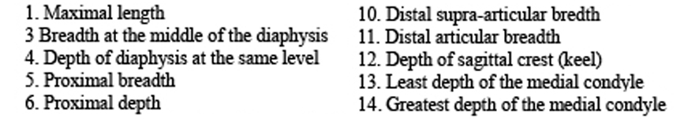

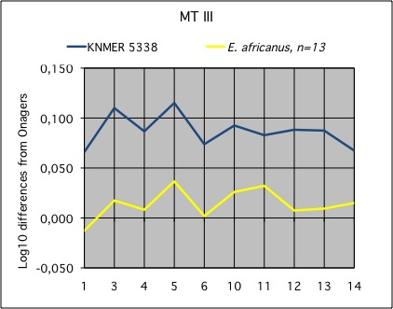

Fig. 18

Figure 18 shows how a MT III from Koobi Fora referred to *Allohippus* *koobiforensis* (about 1.8 My) differ from the reference *E. hemionus onager*, by size and proportions. KNM ER 5338 is bigger (all measures), wider in the diaphysis, and the proximal an distal extremities (measures 3, 5, 10, and 11). It is also bigger than the extant African Wild Ass but has similar proportions.